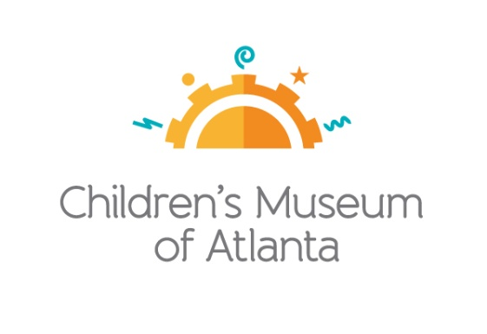

**FOR MORE INFORMATION:**

Sarah Wynn Benton

BRAVE Public Relations

404.233.3993

[sbenton@emailbrave.com](mailto:sking@bravepublicrelations.com)

**\*MEDIA ADVISORY\***

**Tickets on Sale Now for Children’s Museum of Atlanta’s Annual Trick-or-Treat   
on Oct. 19 and 26**

*Families invited to get into the spooky spirit during multi-weekend Halloween celebration!*

**ATLANTA (Sept. 9, 2024) –** *Summoning all ghouls, goblins, gremlins!* **Children’s Museum of Atlanta** is hosting its annual **Trick–or–Treat**, and it’s larger and more spectacular than ever before. **Saturday, Oct. 19 and Saturday, Oct. 26** from **5:30 – 7:30 p.m.,** families can look forward to frightfully fun crafts, a costume parade, a live DJ playing Halloween hits, trick-or-treating and much more! Kids and grown-ups are encouraged to dress up in their best Halloween costumes. Tickets are $10 for members and $25 for non-members. Advance tickets are required; no tickets will be sold at the door. This is a *fa-boo-lous* event … that’s sure to sell out quickly!

**WHAT: Tickets on Sale for****Annual Trick-or-Treat at The Children’s Museum of Atlanta**

*Families have an exciting lineup ahead, featuring spooky and enjoyable crafts, a costume parade, DJ Dewayne, trick-or-treating and other thrilling activities!*

**WHEN: Saturday, Oct. 19 and Saturday, Oct. 26**

5:30 – 7:30 p.m.

**WHERE: The Children’s Museum of Atlanta**

275 Centennial Olympic Park Drive, NW

Atlanta, GA 30313

**HOW:** Tickets are $10 for members and $25 for non-members. Space is limited and tickets will not be sold at the door. Prices will increase week of event. To purchase tickets, please visit: [bit.ly/trickortreat2024](https://bit.ly/trickortreat2024).

Images: [Here](https://drive.google.com/drive/folders/1ZhKGCVaN8Fwn5y2Ol-Pai-U9ufOBQIUA?usp=sharing)

For more information, visit [childrensmuseumatlanta.org](http://childrensmuseumatlanta.org) or call 404.659.KIDS (5437)

**###**